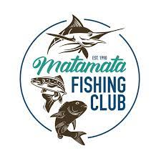

**Hunting Competition**

***Supported by Waikato Stud***

**Starts 1pm Friday 5th July**

**Weigh in 2-4pm Sunday 7th July @ Matamata Fishing Club**

(You must be in line by 4pm)

**Enter at Matamata Sportsworld or by filling out the form and emailing to** [**g.s.atkinson@farmside.co.nz**](mailto:g.s.atkinson@farmside.co.nz)

Every Adult entered goes into the draw to win a Garmin GPSMap

**Entry Fee –**

**Fishing Club Members $20.00 Adult**

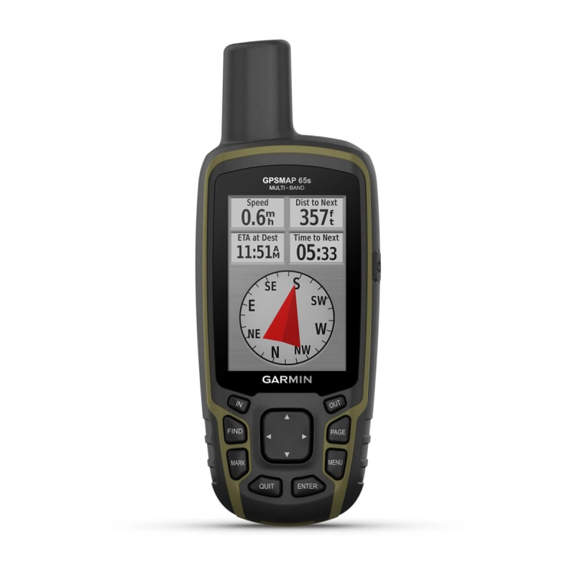**Non-members $40.00 Adults**

**Kids 16 years and under $5.00**

**Entry fee to be paid at time of entry or to**

**Bank Account - 06-0361-0083382-02**

**Cash Bar Only – NO BYO**

**over $7,000 worth of Prizes**

**Categories:**

**Adult Heaviest, Average & Closest to Average Weight**

**Pig, Red Deer, Fallow Deer**

**Heaviest Sow**

**Ladies Heaviest**

**Kids: Heaviest Rabbit, Hare, Possum**

***ANY ENQURIES CONTACT STEF: 027 654 0207 or EILEEN: 027 368 3354***

**Rules for Hunting Competition at Matamata Fishing Club July 2024**

***Supported by Waikato Stud***

Start Date 1pm Friday 5th July

Weigh in time 2pm – 4pm *(You must be in line by 4pm)*

Entry fee - Fishing Club Members $20.00 Adults Non-members $40.00 Adults

Kids 16years and under $5.00

Entries at Matamata Sportsworld or by filling out form

Entry Fee to be paid at time of entry

Entries open 1st May - Close 1st July at 5pm

Lucky Adults Hunters Draw [Garmin GPSmap] – You must be there to win

Categories:

Red Deer & Fallow Deer - Heaviest, 2nd Heaviest, Average Weight & Closest to Average Weight, Ladies Heaviest

Pigs – Heaviest, 2nd Heaviest, Average Weight & Closest to Average Weight, Ladies Heaviest, Heaviest Sow

*Minimum Weight for Pigs is 25kg gutted*

Kids: Rabbit, Hare, Possum - 1st Heaviest 2nd Heaviest 3rd Heaviest

1 animal per category (you can only enter in 1 age category - Adult or Kids)

* All animals to be offal free with heads on,
* All boars to have balls and ball bag attached,
* No Barrows
* No rotten or heavily dog damaged animals
* Absolutely no pen reared, frozen or domestic animals.

**All game remains the property of the hunter and must be removed at the end of prize giving**.

In the event 2 animals weigh the same the 1st animal weighed in wins the prize.

**JUDGES DECISION IS FINAL**

Sponsored by: **Paul Jones Contracting, Jimmy Neal Electrical, Joanne Morgan,**

**Henry Clifton, Matamata Glass and Joinery, Doctor Trim, Bryan Shepherd {Top Cru}, Matamata Butchery, Steve & Linda Dench, Matamata Mowers & Chainsaw, Good Merchant, Shooter Ready, Matamata SportsWorld, Northwood Farm, Matamata Roofing Services Ltd, Takapu Charters, PGG Wrightson, Farmlands, Matamata Stihl Shop, Dave Dunstan, Matamata Mitre 10, Redoubt Matamata, Greg & Eileen Ward, Barrie & Fiona Forsyth**

**ENTRY FORM**

NAME

PHONE

EMAIL

Adults

KIDS

**I have paid the entry fee and agree to abide by the Competition rules.**

**I acknowledge I enter at my own risk**

Signed

Payment Online - **06-0361-0083382-02 –** Please put your name as reference

Email to [**g.s.atkinson@farmside.co.nz**](mailto:g.s.atkinson@farmside.co.nz)

**Keep an eye on the Matamata Fishing Club Facebook page for updates**

**Registrations Close 1st July 5pm**